Southeastern Pennsylvania Synod
Evangelical Lutheran Church in America

Chrism Service
United Lutheran Seminary
March 26, 2024

Gathering
The Holy Spirit Gathers us together
Prelude
Canon in D Johann Pachelbel
Welcome & Invocation
The assembly stands.
Blessed be the holy Trinity, ☩ one God, who looks upon us in compassion, forgives our sin,
and heals our lives.
Amen.
Confession and Forgiveness
Let us confess our sin in the presence of God and of one another.
Silence is kept for reflection.

Have mercy, O God,
against you, you alone, we have sinned.
In your compassion, cleanse us from our sin and take away our guilt.
Create in us a new heart
and give us a steadfast spirit.
Do not cast us away,
but fill us with your Holy Spirit
and restore your joy within us.
Amen.

As tender as parent to child,
so deep is God’s compassion for you.
As high as heaven is above earth,
so vast is God’s love for you.
As far as east is from west,
so far God removes your sin from you,
renewing your life through Jesus Christ.
Blessed be God who crowns us with mercy and love.
Blessed be God forever.

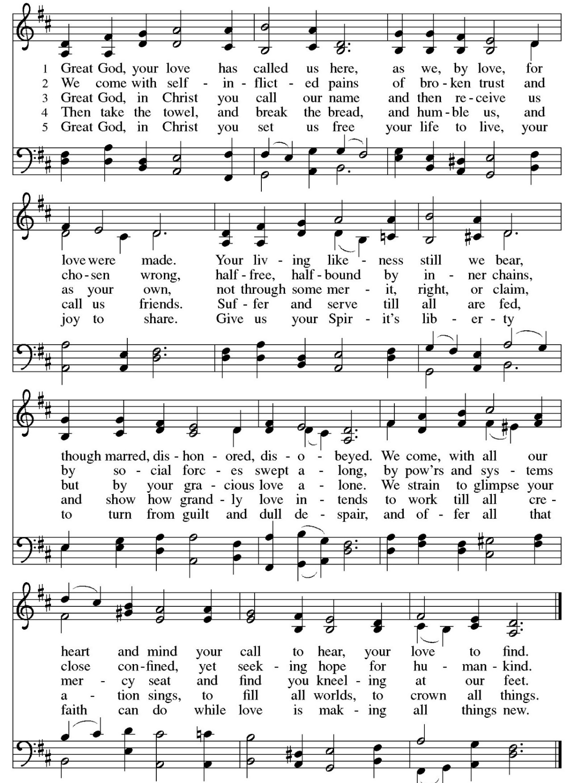
Opening Song Great God, Your Love Has Called Us ELW 358
Apostolic Greeting
The grace of our Lord Jesus Christ, the love of God,
and the communion of the Holy Spirit be with you all.
And also with you.

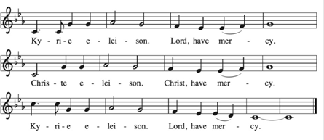
Kyrie

Prayer of the Day
The assembly responds
Amen.
The assembly may be seated

Word
God speaks to us in scripture reading, preaching, and song.
First Lesson Isaiah 49:1-7
Here the servant, identified as Israel, speaks for herself and describes her honored mission. Called before her birth like Jeremiah and John the Baptist, the servant is not only to restore Israel. The servant’s ultimate assignment is to bring news of God’s victory to the ends of the earth. God in faithfulness has chosen Israel for this task.
A Reading from Isaiah,

Listen to me, O coastlands;
pay attention, you peoples from far away!
The Lord called me before I was born;
while I was in my mother’s womb he named me.
² He made my mouth like a sharp sword;
in the shadow of his hand he hid me;
he made me a polished arrow;
in his quiver he hid me away.
³ And he said to me, “You are my servant,
Israel, in whom I will be glorified.”
⁴ But I said, “I have labored in vain;
I have spent my strength for nothing and vanity;
yet surely my cause is with the Lord
and my reward with my God.”
⁵ And now the Lord says,
who formed me in the womb to be his servant,
to bring Jacob back to him,
and that Israel might be gathered to him,
for I am honored in the sight of the Lord,
and my God has become my strength—
⁶ he says,
“It is too light a thing that you should be my servant
to raise up the tribes of Jacob
and to restore the survivors of Israel;
I will give you as a light to the nations,
that my salvation may reach to the end of the earth.”
⁷ Thus says the Lord,
the Redeemer of Israel and his Holy One,
to one deeply despised, abhorred by the nations,
the slave of rulers,
“Kings shall see and stand up;
princes, and they shall prostrate themselves,
because of the Lord, who is faithful,
the Holy One of Israel, who has chosen you.”
Word of God, Word of Life
Thanks be to God.

Psalmody Psalm 71:1-14
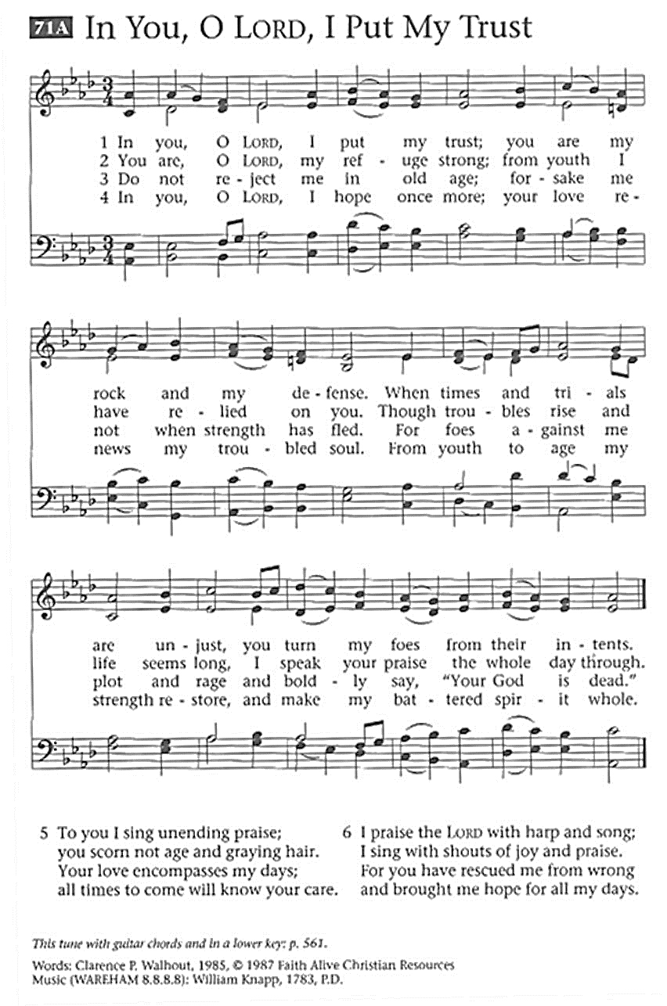
Second Reading 1 Corinthians 1:18-31
To the world, the word of the cross is silly, because it claims God’s power is most fully revealed in complete, utter weakness. For those who are being saved, however, the word of the cross unveils God’s true wisdom, power, and source of true life.

A reading from First Corinthians,

¹⁸The message about the cross is foolishness to those who are perishing, but to us who are being saved it is the power of God. ¹⁹For it is written,
“I will destroy the wisdom of the wise,
and the discernment of the discerning I will thwart.”
²⁰Where is the one who is wise? Where is the scribe? Where is the debater of this age? Has not God made foolish the wisdom of the world? ²¹For since, in the wisdom of God, the world did not know God through wisdom, God decided, through the foolishness of our proclamation, to save those who believe. ²²For Jews demand signs and Greeks desire wisdom, ²³but we proclaim Christ crucified, a stumbling block to Jews and foolishness to Gentiles, ²⁴but to those who are the called, both Jews and Greeks, Christ the power of God and the wisdom of God. ²⁵For God’s foolishness is wiser than human wisdom, and God’s weakness is stronger than human strength.
²⁶Consider your own call, brothers and sisters: not many of you were wise by human standards, not many were powerful, not many were of noble birth. ²⁷But God chose what is foolish in the world to shame the wise; God chose what is weak in the world to shame the strong; ²⁸God chose what is low and despised in the world, things that are not, to reduce to nothing things that are, ²⁹so that no one might boast in the presence of God. ³⁰God is the source of your life in Christ Jesus, who became for us wisdom from God, and righteousness and sanctification and redemption, ³¹in order that, as it is written, “Let the one who boasts, boast in the Lord.”

Word of God, Word of Life
Thanks be to God.

Gospel Acclamation
The Assembly rises to welcome the gospel
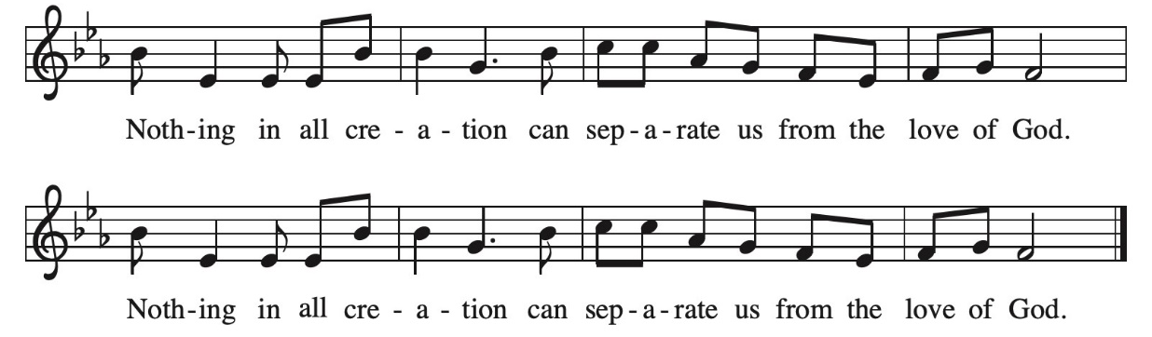
Gospel Reading John 12:20-36
Knowing that his hour has come, Jesus announces that his death will be an exaltation. When he is lifted up in death, drawing people to new life, God’s name will be glorified.

The Holy Gospel According to John,
Glory to you O Lord.

²⁰Now among those who went up to worship at the festival were some Greeks. ²¹They came to Philip, who was from Bethsaida in Galilee, and said to him, “Sir, we wish to see Jesus.” ²²Philip went and told Andrew; then Andrew and Philip went and told Jesus. ²³Jesus answered them, “The hour has come for the Son-of- Man to be glorified. ²⁴Very truly, I tell you, unless a grain of wheat falls into the earth and dies, it remains just a single grain; but if it dies, it bears much fruit. ²⁵Those who love their life lose it, and those who hate their life in this world will keep it for eternal life. ²⁶Whoever serves me must follow me, and where I am, there will my servant be also. Whoever serves me, the Father will honor.
²⁷“Now my soul is troubled. And what should I say—‘Father, save me from this hour’? No, it is for this reason that I have come to this hour. ²⁸Father, glorify your name.” Then a voice came from heaven, “I have glorified it, and I will glorify it again.” ²⁹The crowd standing there heard it and said that it was thunder. Others said, “An angel has spoken to him.” ³⁰Jesus answered, “This voice has come for your sake, not for mine. ³¹Now is the judgment of this world; now the ruler of this world will be driven out. ³²And I, when I am lifted up from the earth, will draw all people to myself.” ³³He said this to indicate the kind of death he was to die. ³⁴The crowd answered him, “We have heard from the law that the Messiah remains forever. How can you say that the Son-of-Man must be lifted up? Who is this Son-of-Man?” ³⁵Jesus said to them, “The light is with you for a little longer. Walk while you have the light, so that the darkness may not overtake you. If you walk in the darkness, you do not know where you are going. ³⁶While you have the light, believe in the light, so that you may become children of light.”
After Jesus had said this, he departed and hid from them.

The Gospel of our Lord
Praise to you O Christ.
Sermon Bishop Patricia Davenport

Hymn of the Day Where Charity and Love Prevail ELW 359
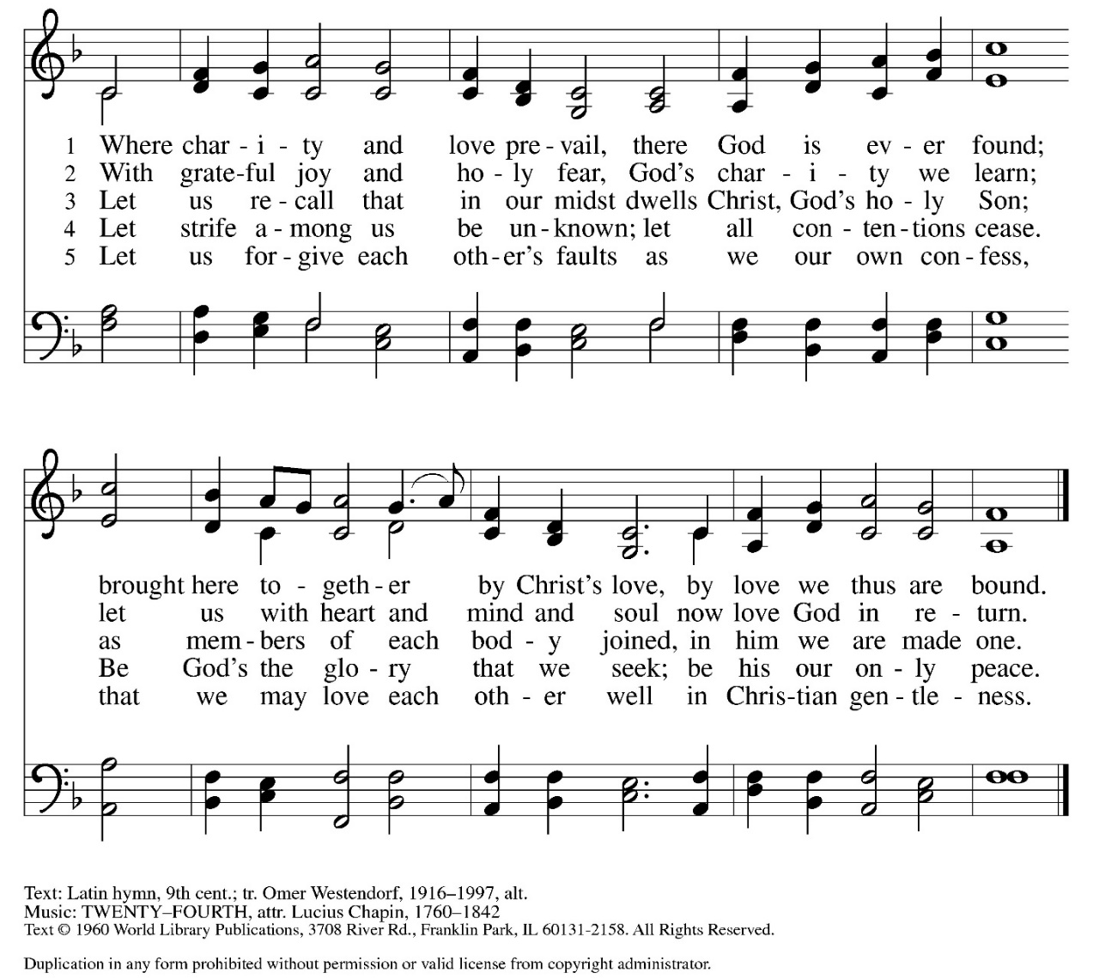
Renewal of Vows
The Bishop leads the assembly in affirming their ministry vows.
Are you resolved to live out your baptismal covenant, and will you endeavor to pattern your life and service after our Lord Jesus?
I am so resolved.
The assembly may be seated and each of the rostered ministers are invited forward; first the roster of Word and Service, then the Congregational Deacons/ Assisting Ministers, and then the roster of Word and Sacrament, each responds in to the questions,
I am so resolved.
Bishop continues,
And now, as your Bishop, before God and this assembly, I re- dedicate myself and reaffirm the promises that I made when I was ordained. I ask your prayers for God’s grace and guidance.

Let us pray.
Almighty God, look with favor upon these persons in their commitment to serve in Christ’s name. Give them courage, patience, and vision; strengthen them in their vocations of witness to the world and of service to others; empower them to be ministers of your reconciliation, love, hope and justice; through Jesus Christ our Lord. Amen.

My siblings in Christ: I pray for you, asking God to bless you with the fullness of the Holy Spirit that you may all be faithful ministers of Christ and that God’s Word may be proclaimed and God’s grace may be made known by your lives.
Our Bishop, Patricia, we pray also for you that you may faithfully fulfill the office to which you have been called, that you may speak the Word boldly and guide the church faithfully as a true shepherd of the flock and a faithful servant of Christ.

May the love of our Lord Jesus Christ keep you close to him always and bring us all to everlasting life. Amen.
The Prayers of Intercession
Sustained by God’s abundant mercy, let us pray for the church, the world, and all of creation.
A brief silence.
Each petition ends. Merciful God, receive our prayer.
Prayers are concluded
We lift our prayers to you, O God, trusting in your steadfast love and your promise to renew your whole creation; through Jesus Christ our Savior.
Amen.
The Offering
The offering is designated for The Bishop’s Fund.
Please make checks payable to the Southeastern Pennsylvania Synod.
The Bishop’s Fund is used to help rostered and professional leaders, and their families who face emergency situations, or need assistance.
The Blessing of the Oil
The Bishop prays and blesses the oil.
Those wishing to receive anointing with the healing oil may come forward during the Anointing Hymn for a blessing to one of the stations near the chancel.
You are invited to take a vial of oil as you return to your seat for use in your ministry.
Anointing Hymn Take O Take Me As I Am ELW 814
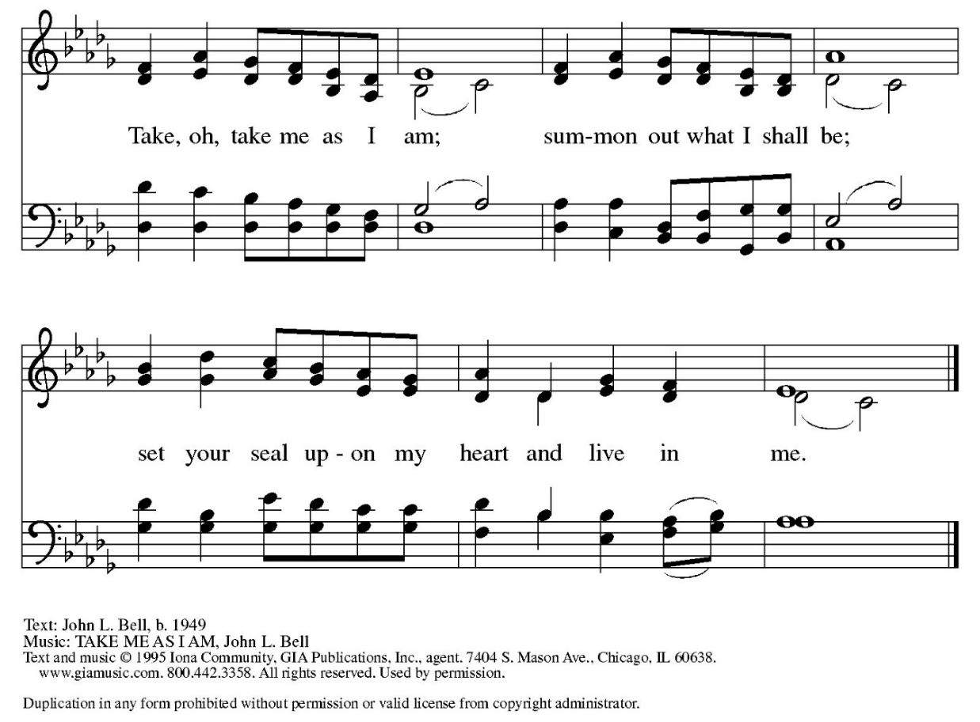

Meal
God feeds us with the presence of Jesus Christ
The Great Thanksgiving
The Lord be with you.
And also with you.
Lift up your hearts.
We lift them to the Lord.
Let us give thanks to the Lord our God.
It is right to give our thanks and praise.
It is indeed right, our duty and our joy, that we should in all times and in all places, give thanks and praise to you, almighty and merciful God, through our Savior Jesus Christ. You call your people to cleanse their hearts, and to prepare for the paschal feast, that renewed in the gift of baptism we may come to the fullness of your grace. And so with all the choirs of angels, with the church on earth and the hosts of Heaven we praise your name and join their unending hymn: 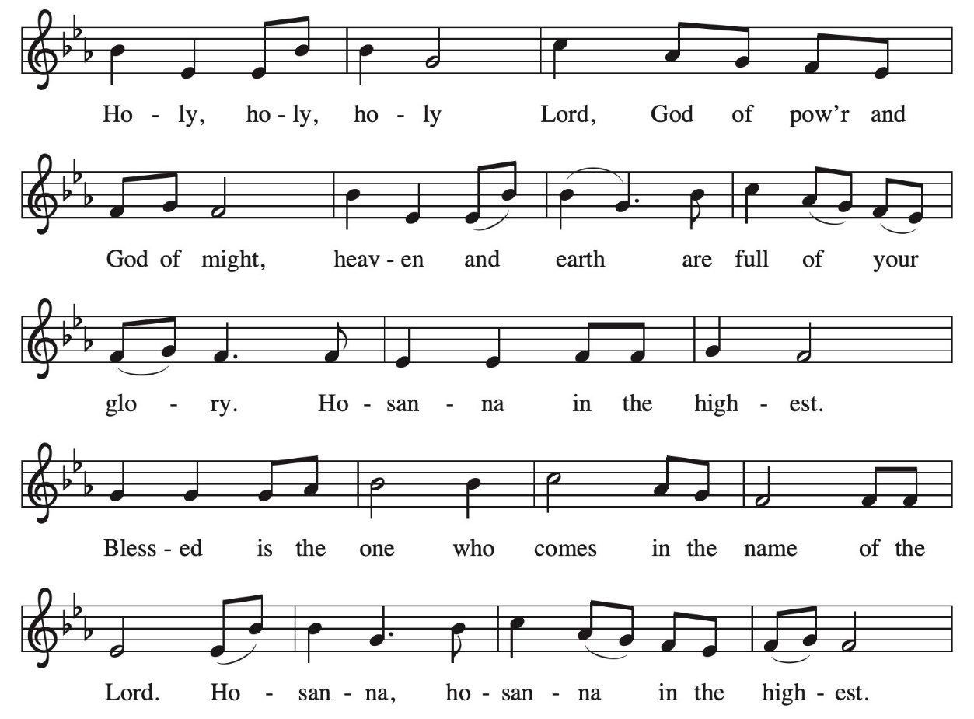

…In the night in which he was betrayed our Lord Jesus took bread, and gave thanks; broke it, and gave it to his disciples, saying: Take and eat; this is my body, given for you. Do this for the remembrance of me.

Again, after supper, he took the cup, gave thanks, and gave it for all to drink, saying: This cup is the new covenant in my blood, shed for you and for all people for the forgiveness of sin. Do this for the remembrance of me…

The Lord’s Prayer
Lord remember us in your kingdom and teach us to pray,
Our Father in heaven,
hallowed be your name,
your kingdom come,
your will be done,
on earth as in heaven.
Give us today our daily bread.
Forgive us our sins
as we forgive those
who sin against us.
Save us from the time of trial
and deliver us from evil.
For the kingdom, the power,
and the glory are yours,
now and forever. Amen.
Invitation to Communion
Come to the Banquet for all is now ready.
Assembly may be seated as we come forward for communion.

Lamb of God
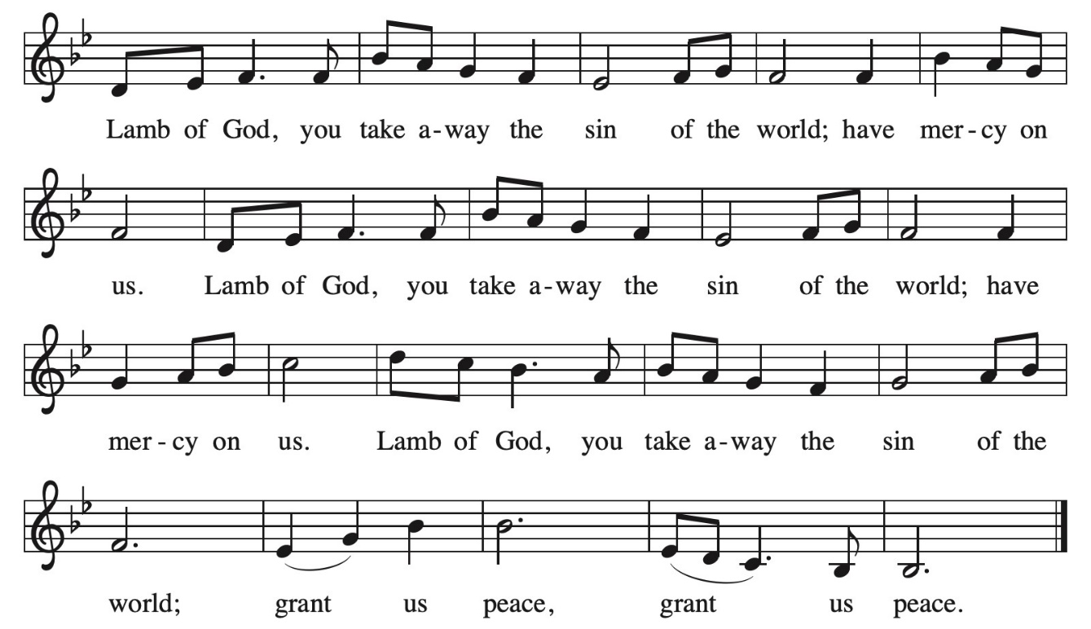
Communion Songs I Want Jesus to Walk with Me TFF 66 ELW 325
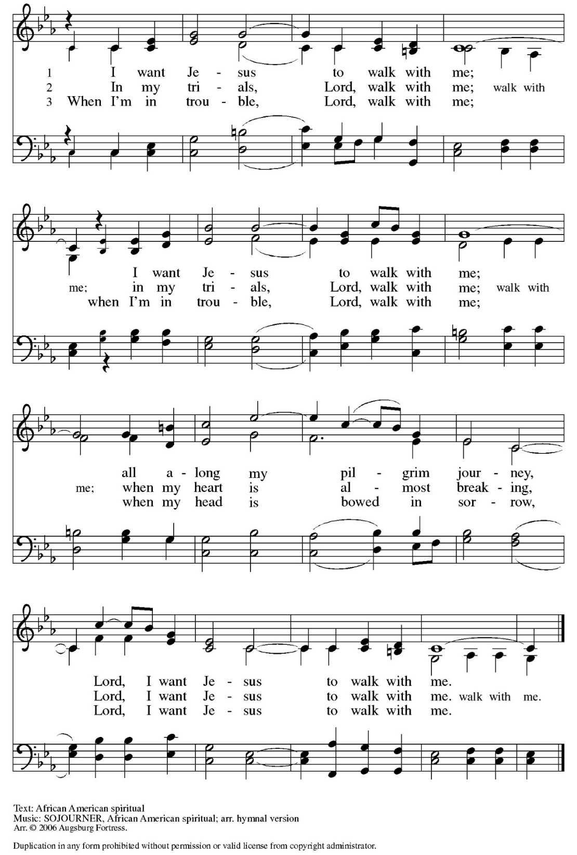
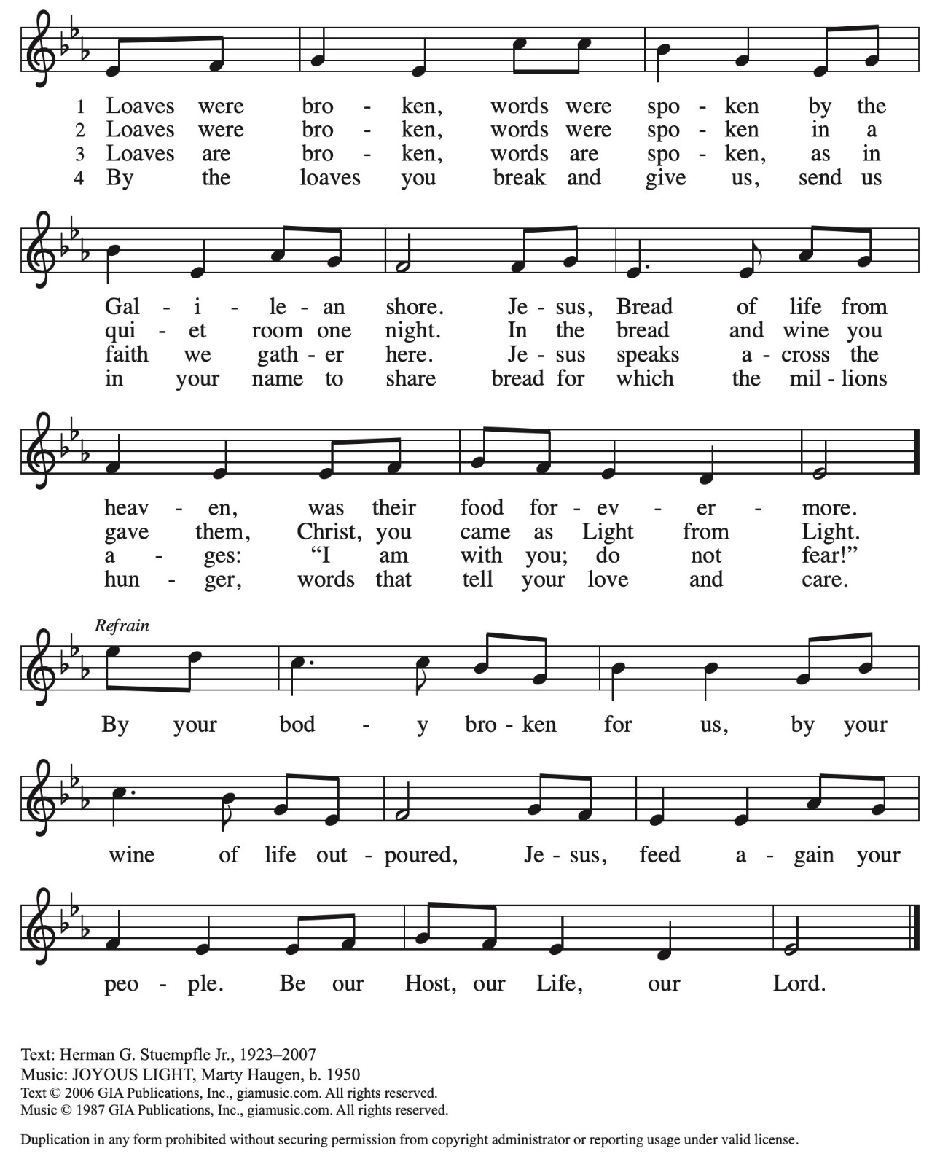
Loaves Were Broken Words Were Spoken ACS 966
Post Communion Prayer
We thank you, O God, that you have strengthened our hearts through this feast of life and salvation. Shine the light of Christ on our path, that we may do justice, love kindness, and walk humbly with you, now and forever. Amen.

Sending
God blesses us and sends us in mission to the world
Blessing
The peace of God,
which surpasses all understanding, keep your hearts and your minds in ☩ Christ Jesus.
Amen.

Sending Song Lord Jesus, You Shall Be My Song ELW 808
Dismissal
Go in peace. Serve the Lord.
Thanks be to God.
Postlude
Psalm IXI Benedetto Marcello

Please join us next door in the Brossman Center for a luncheon reception
following the worship service.

Serving in Worship
Presiding & Presiding | The Rev. Patricia Davenport,  SEPA Synod Bishop
Worship Assistants | Allison Overly-Stokes, United Lutheran Seminary  Grace Robinson, Wartburg Seminary  Deivis Ventura, United Lutheran Seminary  Conner J. Watson, United Lutheran Seminary  Chris Walker, United Lutheran Seminary
Organist | The Rev. Bruce Todd,  Retired

Service of Holy Communion from Evangelical Lutheran Worship ©2006 Evangelical Lutheran Church in America, admin. Augsburg Fortress, and All Creation Sings © 2020 Evangelical Lutheran Church in America, admin. Augsburg Fortress. Additional texts from Sundays and Seasons © 2023 Augsburg Fortress. All rights reserved. Reprinted by permission under Augsburg Fortress Annual Licenses SA
SAS006887.

Gathering Song: “Great God Your Love Has Called Us”, Text © 1977, rev. 1995 Hope Publishing Company. All rights reserved.

Music and Texts reprinted and streamed by permission under OneLicense.net# A-713089 and CCLI
License # 2520458 / CSPL088234

Scripture quotations from the NRSV Bible, Copyright © 1989, Division of Christian Education of the National Council of churches of Christ in the United States of America, adapted and edited with permission.

