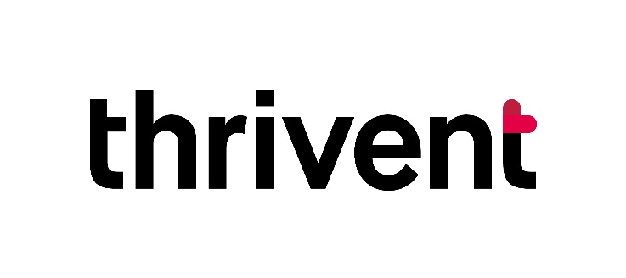
People thrive when they make the most of all they have been given. Thrivent is committed to helping those we serve – individuals, churches, and nonprofits – make informed financial decisions based on Christian values. We believe money is a tool, not a goal. We’re honored to offer churches unique resources to help you manage ongoing operations to carry out your mission and strengthen our communities.
We’re excited to report:
- Thrivent directed $289,493 in Choice Dollars to more than 450 churches and nonprofits in the five-county Southeastern Pennsylvania Synod district in 2020.
- Thrivent Action Teams continue to support church missions and outreach by engaging congregation members in service, educational and fundraising volunteer projects.
- Churches in the SEPA Synod district are invited to join us in a Faith Builds in partnership with local Habitat for Humanity affiliates. Join us in raising prayers, walls, and donations as we build a duplex home for hard-working families on Cowpath Road in Hatfield in 2021. To learn more, visit: https://habitatmontdelco.org/thrivent/. And celebrate with us as we look to bless two families, welcoming them home to two completed Faith Builds homes in Coatesville, Chester County soon!
- Financial education workshops and webinars help strengthen congregations through values-based teaching on topics ranging from budgeting, saving, goal setting, and teaching children and teens money concepts – to more advanced topics such as college saving, retirement planning, and legacy and charitable giving strategies. More than 40+ offerings are available at no cost to congregations.
- Our Thrivent Member Network Mid-Atlantic provides additional opportunities for fellowship, inspiration, education, and generosity. Highlights include periodic webinars geared toward church leaders held in partnership with Barna Research Group, faith testimony from athlete Tim Tebow, and inspiration from Nashville Christian recording artist Matthew West. Visit: Thrivent.com/Mid-Atlantic for a complete listing of upcoming events. No products are ever sold at events.
- Thrivent was honored to be named one of the World’s Most Ethical Companies by Ethisphere in 2021 – our tenth year in a row. We’re proud of our 100+-year history of strength and stability, and we’re committed to continuing to provide practical financial guidance, investments, insurance, banking, church financing, endowment, and charitable giving solutions.
For more information, visit: https://www.thrivent.com/ or contact:
Carolyn Schnizler Wilt
Thrivent Engagement Leader
Greater Philadelphia area
Carolyn.schnizlerwilt@thrivent.com
484-388-0858

