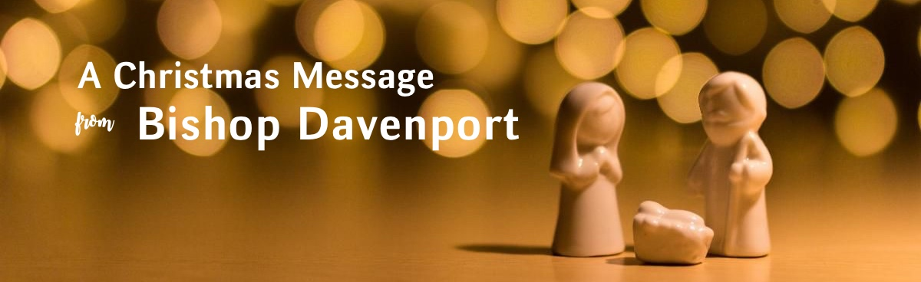

May the God of hope fill you with all joy and peace in believing, so that you may abound in hope by the power of the Holy Spirit.
– Romans 15:13

Beloved,

“It’s about Jesus!”

That was the theme for the ELCA’s exciting Congregational Vitality gathering this year. And it could well be the theme for our celebration of Advent and Christmas 2019. (And perhaps every week of the year, as well.)

In this season we live in the great mystery of already and not yet. We know and trust in the birth of Jesus many centuries ago in Bethlehem. Yet we still symbolically re-live Mary’s surprise at the angel’s news, Joseph’s shock, an arduous journey, the angel’s praise, the flight to Egypt.

At the center, “it’s about Jesus.” Christmas brings the amazingly wonderful news that the creator of the universe stooped and “became flesh and blood, and moved into the neighborhood.” (John 1:14, The Message) It’s the beginning of the last chapter of the salvation story. God stood with us in Bethlehem’s manger, and God still stands with us today as Christ is reborn in our hearts this season.

I pray that re-living the story this year brings you peace and hope as we focus on Jesus.

Love always and always love in Christ,
The Rev. Patricia A. Davenport
Bishop

