A Lenten Message from Bishop Patricia Davenport

Greetings, Beloved.

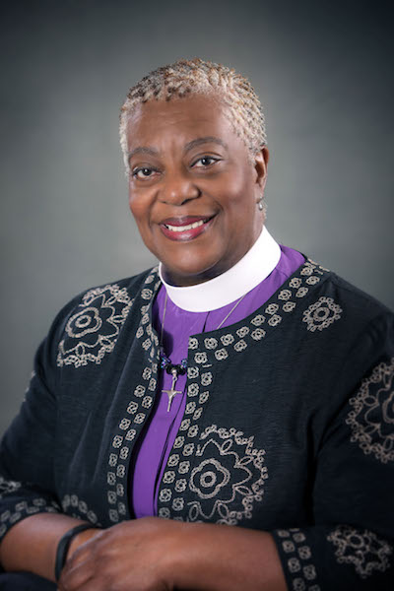
As I ponder my Lenten journey, I was thinking it’s not as much about giving up as it is an invitation to give ourselves over to the love of God; to be aware of our blessings, and our call to share those blessings. In that sense it is a call to action, to recommit to bringing healing and restoration to our communities.

The Lenten season is also an invitation to connect more closely with the triune God so that we all — young, old, men, women, gay, straight, clergy, lay — yes, Beloved, each of us can dream God’s dreams. God has loved us. We will love each other.

Pray with me:

Good and gracious God, bless your children over the next forty days that we might see you more clearly. Speak, Lord, that we might hear your voice over the chatter of the world. Stir your Holy Spirit within our hearts that we might be drawn into a deeper relationship with you that leads to a deeper relationship with others. Use us to your glory, that the Kingdom might be a little bit stronger because of how we serve you. In Jesus’ name. Amen.

In Christ,
Watch this message at https://youtu.be/MmVYw67NHrg
A Lenten Message from Bishop Patricia Davenport

Greetings, Beloved.

As I ponder my Lenten journey, I was thinking it’s not as much about giving up as it is an invitation to give ourselves over to the love of God; to be aware of our blessings, and our call to share those blessings. In that sense it is a call to action, to recommit to bringing healing and restoration to our communities.

The Lenten season is also an invitation to connect more closely with the triune God so that we all — young, old, men, women, gay, straight, clergy, lay — yes, Beloved, each of us can dream God’s dreams. God has loved us. We will love each other.

Pray with me:

Good and gracious God, bless your children over the next forty days that we might see you more clearly. Speak, Lord, that we might hear your voice over the chatter of the world. Stir your Holy Spirit within our hearts that we might be drawn into a deeper relationship with you that leads to a deeper relationship with others. Use us to your glory, that the Kingdom might be a little bit stronger because of how we serve you. In Jesus’ name. Amen.

In Christ,
Watch this message at https://youtu.be/MmVYw67NHrg

