LENTEN FOCUS: GLOBAL MISSION

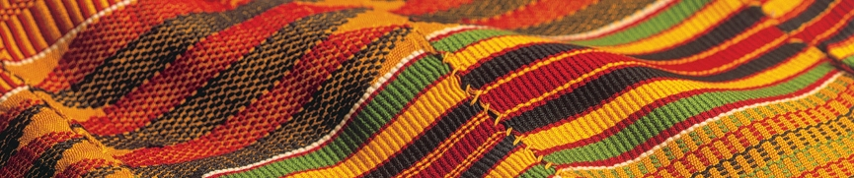

Sebastian Kolowa Memorial University:
North Eastern Diocese of Tanzania

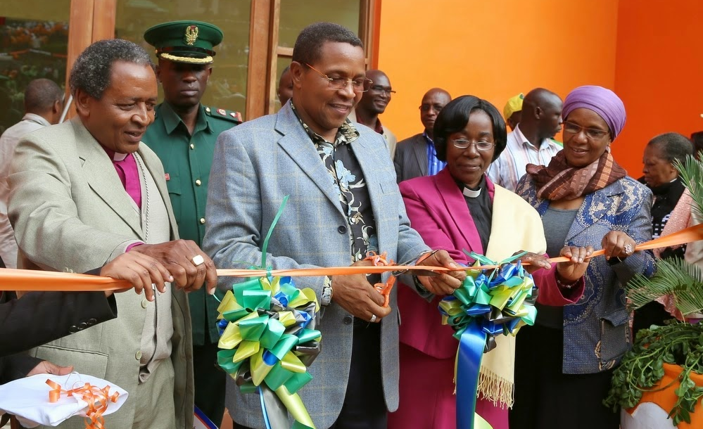

Southeastern Pennsylvania Synod has been involved with the dream of SEKOMU University since the beginning. Nearly 10 years ago, in partnership with our Global Mission partners, the North Eastern Diocese of Tanzania, we helped launch this incredible ministry. This past September, the diocese’s university SEKOMU was tragically attacked and significant damage was done to the property.

This was an unusual and frightening time for SEKOMU and the people of the North-Eastern Diocese, and they continue to rebuild and install key security measures including a guard station and a fence on the university campus. This work is not easy for them and is a stress on their resources – it is challenging enough for them to operate the day-to-day expenses of the school.

The need is still real. Please consider helping protect our friends in Tanzania by assisting them in installing vital equipment to prevent something like this from ever happening again.
LENTEN FOCUS: GLOBAL MISSION

Sebastian Kolowa Memorial University:
North Eastern Diocese of Tanzania

Southeastern Pennsylvania Synod has been involved with the dream of SEKOMU University since the beginning. Nearly 10 years ago, in partnership with our Global Mission partners, the North Eastern Diocese of Tanzania, we helped launch this incredible ministry. This past September, the diocese’s university SEKOMU was tragically attacked and significant damage was done to the property.

This was an unusual and frightening time for SEKOMU and the people of the North-Eastern Diocese, and they continue to rebuild and install key security measures including a guard station and a fence on the university campus. This work is not easy for them and is a stress on their resources – it is challenging enough for them to operate the day-to-day expenses of the school.

The need is still real. Please consider helping protect our friends in Tanzania by assisting them in installing vital equipment to prevent something like this from ever happening again.
THIS LENT…You are invited to be a part of a special project to help support our brothers and sisters in Tanzania to continue the ten year legacy of the university – advocacy, education, and support for those living with special needs and intellectual disabilities in the country of Tanzania!

SEKOMU was targeted because it is a bastion of Christ’s love and hope for all people – women, men, the disabled – and it represents possibilities that some hateful groups do not want people to have. It is now more important than ever that we stand beside SEKOMU and the North Easter Diocese in their witness to Christ’s love.

HOW CAN I HELP?
To help our synod come together to protect Sebastian Kolowa Memorial University (SEKOMU), please follow these instructions:

Option A: Make your check payable to your congregation for your local offering. Put “SEKOMU Support” in the memo line to designate your contribution.

Option B: Make your check payable to SEPA Synod. Put “SEKOMU Support” in the memo line to designate your contribution and mail directly to: Southeastern Pennsylvania Synod, ELCA, 7241 Germantown Ave., Philadelphia, PA 19119

Questions? Please contact Rev. Bradley R. Burke, Assistant to the Bishop, at bburke@sepa.org or 267-323-3762.

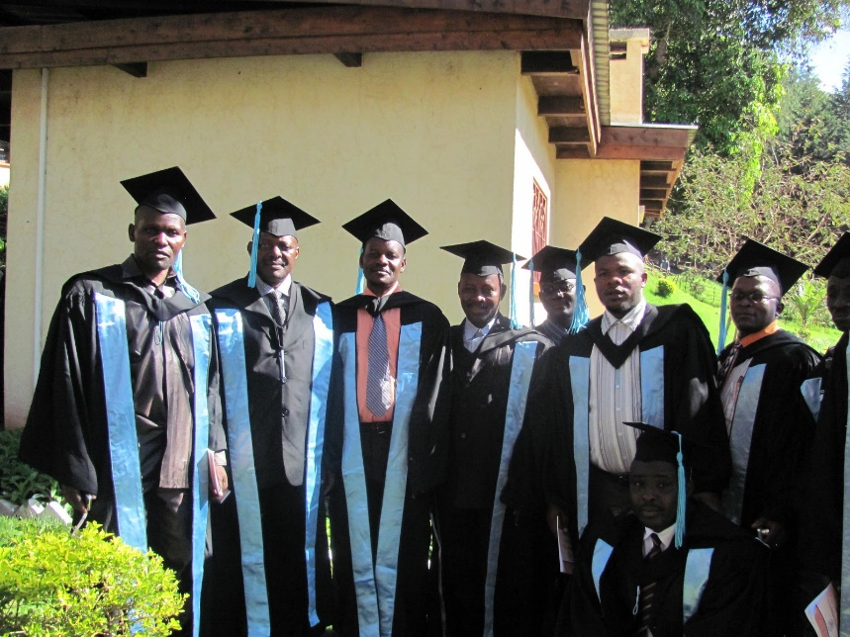
THIS LENT…You are invited to be a part of a special project to help support our brothers and sisters in Tanzania to continue the ten year legacy of the university – advocacy, education, and support for those living with special needs and intellectual disabilities in the country of Tanzania!

SEKOMU was targeted because it is a bastion of Christ’s love and hope for all people – women, men, the disabled – and it represents possibilities that some hateful groups do not want people to have. It is now more important than ever that we stand beside SEKOMU and the North Easter Diocese in their witness to Christ’s love.

HOW CAN I HELP?
To help our synod come together to protect Sebastian Kolowa Memorial University (SEKOMU), please follow these instructions:

Option A: Make your check payable to your congregation for your local offering. Put “SEKOMU Support” in the memo line to designate your contribution.

Option B: Make your check payable to SEPA Synod. Put “SEKOMU Support” in the memo line to designate your contribution and mail directly to: Southeastern Pennsylvania Synod, ELCA, 7241 Germantown Ave., Philadelphia, PA 19119

Questions? Please contact Rev. Bradley R. Burke, Assistant to the Bishop, at bburke@sepa.org or 267-323-3762.

