LENTEN FOCUS: LOCAL MISSION

THE THIRD WORLD DOWN THE STREET
Care Kits for our Homeless Neighbors

“The Third World Down the Street” is a joint project between Southeastern Pennsylvania Synod and the Seminarians Action Alert Network (S.A.A.N.) of The Lutheran Theological Seminary at Philadelphia – and congregations like yours. While we are often aware of the great need of people in countries across the world, many of us don’t realize that across the region people are living in third world conditions. Homelessness is often hidden, and does not always look like we expect. Some of the fastest growing groups of homeless people are youth, young adults, and families. And they need our help.
The idea is simple. We are collecting large zip lock bags with the most common items
that someone experiencing homelessness would need for daily survival.

And that’s where YOU come in!

In late April, members of local congregations and Young Adults from across SEPA Synod will gather and pass out the zip lock bags filled with these basic supplies – along with your love and compassion.

Please consider joining us this Lent to serve the Third World Down the Street. On the back of this insert, you will find instructions and a list of items needed for the kits.
LENTEN FOCUS: LOCAL MISSION

THE THIRD WORLD DOWN THE STREET
Care Kits for our Homeless Neighbors

“The Third World Down the Street” is a joint project between Southeastern Pennsylvania Synod and the Seminarians Action Alert Network (S.A.A.N.) of The Lutheran Theological Seminary at Philadelphia – and congregations like yours. While we are often aware of the great need of people in countries across the world, many of us don’t realize that across the region people are living in third world conditions. Homelessness is often hidden, and does not always look like we expect. Some of the fastest growing groups of homeless people are youth, young adults, and families. And they need our help.
The idea is simple. We are collecting large zip lock bags with the most common items
that someone experiencing homelessness would need for daily survival.

And that’s where YOU come in!

In late April, members of local congregations and Young Adults from across SEPA Synod will gather and pass out the zip lock bags filled with these basic supplies – along with your love and compassion.

Please consider joining us this Lent to serve the Third World Down the Street. On the back of this insert, you will find instructions and a list of items needed for the kits.
Items Needed for Homelessness Kits:
ChapStick | Toothbrush
Toothpaste | Deodorant
Lotion | Razor
Sanitary napkins | Socks
Gloves | Hand sanitizers
Wipes | Granola bars or crackers

We can also use sturdy backpacks, along the lines of the average JanSport. It would be particularly helpful if you are able to collect your kits into a backpack, to aid us as we go out to distribute them!

Feel free to also include a note expressing your love for the recipient or a gift card from places like McDonald’s if you desire.

Please be sure all kits are delivered to the Southeastern Pennsylvania Synod office at 7241 Germantown Ave, Philadelphia no later than April 12, 2017.

Questions? Please contact Rev. Bradley R. Burke, Assistant to the Bishop, at bburke@sepa.org or 267-323-3762.

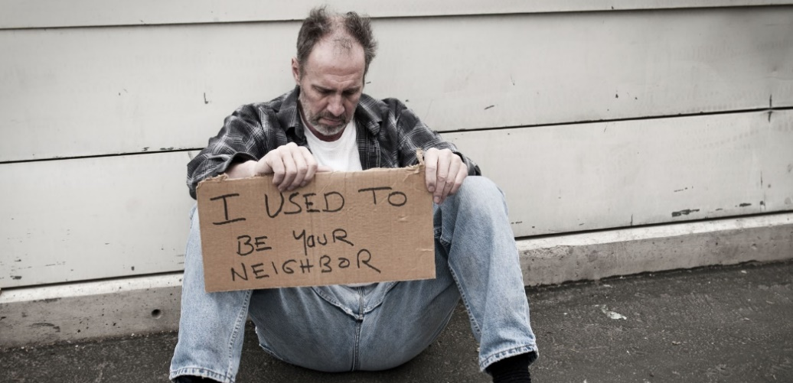

“Lord, when was it that we saw you hungry and gave you food, or thirsty and gave you something to drink? And when was it that we saw you a stranger and welcomed you, or naked and gave you clothing? And when was it that we saw you sick or in prison and visited you?”
-Luke 25: 37-38
Items Needed for Homelessness Kits:
ChapStick | Toothbrush
Toothpaste | Deodorant
Lotion | Razor
Sanitary napkins | Socks
Gloves | Hand sanitizers
Wipes | Granola bars or crackers

We can also use sturdy backpacks, along the lines of the average JanSport. It would be particularly helpful if you are able to collect your kits into a backpack, to aid us as we go out to distribute them!

Feel free to also include a note expressing your love for the recipient or a gift card from places like McDonald’s if you desire.

Please be sure all kits are delivered to the Southeastern Pennsylvania Synod office at 7241 Germantown Ave, Philadelphia no later than April 12, 2017.

Questions? Please contact Rev. Bradley R. Burke, Assistant to the Bishop, at bburke@sepa.org or 267-323-3762.

“Lord, when was it that we saw you hungry and gave you food, or thirsty and gave you something to drink? And when was it that we saw you a stranger and welcomed you, or naked and gave you clothing? And when was it that we saw you sick or in prison and visited you?”
-Luke 25: 37-38

